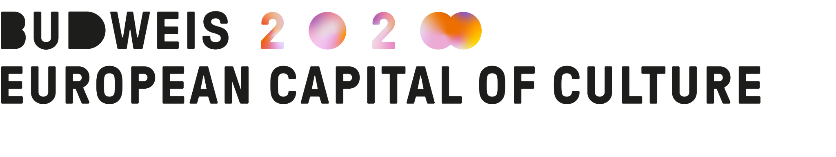As part of the development of the Ars Biologica project, we would like to invite you to a joint visit to the Ars Electronica festival in Linz, Austria.
A one-day trip will take place on Friday 6 September 2024. Transportation there and back will be provided by a shared bus that will depart at 8:30 from České Budějovice and back to České Budějovice will return approximately at 20:30.

What is Ars Biologica?
Ars Biologica is a project of České Budějovice 2028 - the European Capital of Culture, whose goal is to create an environment for the cooperation of science and art, especially in the field of the environment.

Why the Ars Electronica festival?
The Ars Electronica festival is a global leader in connecting art, technology and society. In its 45 years of existence, the festival has developed into one of the most important festivals dedicated to digital technologies and interdisciplinary cooperation. Thanks to this, Ars Electronica is an inspiration for us to connect the worlds of science and art with each other. You can find more information about the festival here.

What will be the program of the visit?
The visit will focus mainly on a tour of the main festival site - the former building of the central Linz post office, Post City. The visit will include a meeting with representatives of the Ars Electronica team, a presentation of the vision of the festival and its current year, and a guided tour of the festival highlights with a focus on works and projects that were created thanks to the collaboration of scientists and artists. In the afternoon, there will be space for independent tours, visits to other festival locations or personal meetings with other partners.
Presentations and guided tours will take place in English or German.
The exact program will be specified based on the number of registrants.

Who is the visit intended for?
The visit is primarily intended for all local partners interested in collaborating on the Ars Biologica project, with the aim of presenting the potential of the project connecting the fields of art and science, showing the possibilities of interdisciplinary cooperation and communication of its outputs for experts and the general public. In addition to cultural organizations, we would also like to invite scientific research institutions and universities to participate, especially the Biological Center of the Academy of Sciences of the Czech Republic and the University of South Bohemia. The visit is also intended for other partners from the field of public administration, the private sector and others. In case of great interest, the relevance of the potential outputs of the cooperation will be taken into account.

How to log in?
You can sign up by filling out a simple REGISTRATION FORM, until August 5, 2024. In case that capacities are not filled, the deadline may be extended.

České Budějovice 2028 - EHMK pays for participants' bus transportation to and from Linz, a one-day entry to the Ars Electronica festival and a guided tour. Other means of transport to Linz and/or back, entrance to accompanying events of the festival, diets and other associated costs with a visit to the festival, participants pay for themselves, e.g

If necessary, you can contact ČB28 program manager Matěj Vlašánek.
AND matej.vlasanek@budejovice2028.cz, T +420 731 936 327.

