Reporting of pathological behavior

Introduction
This document containing summary information on pathological phenomena was created in response to the results of a questionnaire survey conducted in June 2022 by the Ministry of Labour and Social Affairs of the Czech Republic as part of the STOPPER project in which the Biological Centre (hereinafter referred to as BC) was involved. The questionnaire survey indicated that the rate of pathological phenomena was comparable to other participating entities. Based on the results, it can be concluded that employees directly face discrimination and bullying at BC or have faced it in the past in various forms (see graphs 1 and 2 in the Annex).
However, to a much greater extent, staff reported having witnessed bullying in the past 6 months (see graph 3 in the Annex) and for some manifestations, BC's results differ from other institutions by up to 11 percentage points.
In addition, more than 52% of staff do not know what they should do if they are targeted or witness bullying (see graph 4 in the Annex). Therefore, below you will find an explanation and description of the most frequently occurring pathological phenomena in the workplace, together with the procedure on how and where to submit your complaint for investigation.

Discrimination
Any denial of an individual's access to opportunities and rights that are generally available and applicable to all employees may be considered discriminatory conduct. It is considered discrimination to define an individual based on the difference (gender, nationality, age, sexual orientation, race, religion, health status, etc.) To commit discrimination is in direct contravention of the Charter of Fundamental Rights and Freedoms, which is the basis for the so-called anti-discrimination law - Act No. 198/2009 Coll., the Act on Equal Treatment and Legal Means of Protection against Discrimination and Amendments to Certain Acts.

Bullying
Bullying is a dangerous socially pathological phenomenon in which freedom and decision-making are restricted, human dignity and honor are humiliated, and victims are often harmed in terms of health or property. It refers to a variety of physical and psychological abuse of a weaker or different individual in a collective or society. Usually, the aggressor has physical, numerical, or power superiority over the victim. In addition to the victim, the consequences of bullying are passed on to everyone else involved.
Bullying behavior can be considered as bullying if it lasts for more than 6 months and is repeated on average once a week.
Bullying behavior undermines an individual's inner integrity, humiliates them, and can cause health problems if it occurs over a long period. At the same time, the individual's or the team's performance is reduced.

Unconscious bullying
Most often, the person concerned may not even be aware that his or her behavior is causing discomfort to someone in his or her environment. Very often this involves different demands for optimum working temperature, light levels, noise levels, failure to maintain personal hygiene, excessive use of perfume, inadequate emotional displays or language. It is always the case that until we define the problem it is unconscious bullying - we cannot automatically assume that someone is doing us wrong. Nor can we expect the phenomenon to go away on its own without a clear statement and description of what bothers us.

Conscious bullying
We consider deliberate, pathological bullying to be behavior where the person in question continuously, and repeatedly harms colleagues at work. Even after being warned, the bullying continues, often very subtly.

Table 1: Types of conscious bullying
 | Explanation | Example
Mobbing | Bullying between colleagues | Gossiping among colleagues, hiding things, smirking or hushing the conversation when the person enters the room, withholding information, exclusion from the team, teasing, questioning work performance and competence...
Bossing | Bullying of subordinates by superiors (can be directed at an individual or a group) | Assigning tasks with meaningless deadlines, unreasonable criticism, humiliation (e.g. at joint meetings), withholding information, excessive control, threat of dismissal, questioning performance and competence...
Staffing | Bullying of a superior by subordinates | Gossiping, spreading fabricated information to weaken the position of the leader, deliberately ignoring assigned tasks, questioning authority...
Chairing | Power struggles among managers to achieve a higher position | Gossip, ridicule, manipulation, intrigue, questioning of work results and competence, threats...
Sexual harassment | Attack on the intimacy of the individual | Verbal in nature (inappropriate, humiliating jokes, comments, suggestions, blackmail, threats)  Physical in nature (unwanted touching, intrusion into personal zone)

Prevention
The most basic prevention is substantive, assertive and tactful communication to point out what we feel is unpleasant behavior, and actions on the part of the other person. Setting boundaries in behavior and actions, knowing how to say 'no' is also an integral part of this.
Recommended preventive steps (according to the e-learning materials available for the STOPPER project):
- Prevent and avoid attacks, do not provoke conflicts in the workplace.
- Self-reflection
- Don't take everything personally - have a healthy bar of resistance to stress, criticism
- Learn the benefits of substantive criticism
- Seek to recognize the causes that could trigger relational pathology.
- Try to resolve conflicts immediately and confront the colleague with his/her unpleasant or unethical behaviour = setting tolerance and communication boundaries
- Not to be provoked.
- Strengthen your positive side.
- Be aware of your weaknesses, shortcomings, but build on your strengths.
- In case of relational pathology, put distance from the problem and try to communicate clearly, assertively, openly.
- Focus on work that is creative and positive for the communicator.

Reporting

Who to contact?
If your efforts at substantive communication fail and the attacks on you continue, take your complaint first to your immediate supervisor or the next higher supervisor (if you have a conflict with your immediate supervisor). He or she should discuss the situation with you and take it forward as appropriate. You can also contact the Ethics Committee directly (see below).

Ethics Committee
The Ethics Committee is the body responsible for dealing with allegations of unethical conduct and behaviour at BC. The Ethics Committee is composed of six members (each Institute and TAS has a representative). The current composition is available on the intranet at https://www.bc.cas.cz/intranet/interni-dokumenty/rada-reditele/rada-reditele-zapisy-2021-2027/rok-2022/zapis-c-7-2022/
The Ethics Committee considers complaints in accordance with the Code of Ethics. The Code of Ethics is a binding document for all BC employees and is made known to employees upon their entry into employment. https://www.bc.cas.cz/en/intranet/internal-documents/regulations-and-directives/#anchor
In less serious cases, the Ethics Committee seeks primarily to conciliate with both parties, acting as a mediator. In serious cases, it investigates the complaint and submits the result of the investigation to the Director of the institution and the institute concerned. Disciplinary action is then the responsibility of the directors.
In the situation that the complaint is dealt with only by the Head and consequences will be drawn, it is important to consult the Head of Human Resources on the legislative framework for disciplinary matters to ensure that everything is in line with the Labour Code and that there is no conflict.

What to do if I witness bullying and want to report it for investigation:
- I will document, record the date, time, and event I witnessed
- I will describe who was bullied and who was the bully (victim and aggressor)
- If there are other witnesses, I will include them in my record
- I will describe the situation in as much detail as possible (but I will avoid assumptions and speculation, I will only describe what I was directly involved in)
- If this is not the first time and the situation has been repeated several times, I will state the frequency of the phenomenon as precisely as possible
- If I have evidence, I will attach it to the description
- The complaint can be submitted directly to the Ethics Committee, which will deal with the complaint https://www.bc.cas.cz/intranet/komise/eticka-komise/#anchor
- Any consultation on the drafting of the complaint is possible together with the HR Activities Coordinator or the BC Secretary

Annex
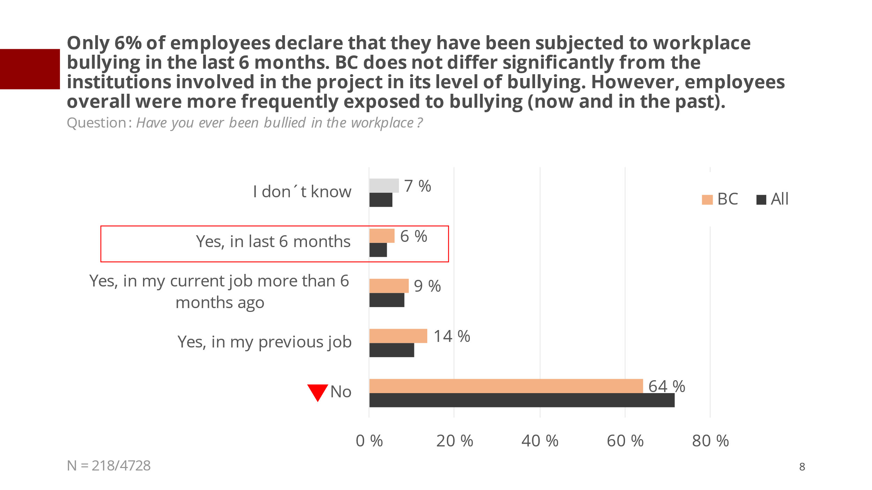
Graph 1

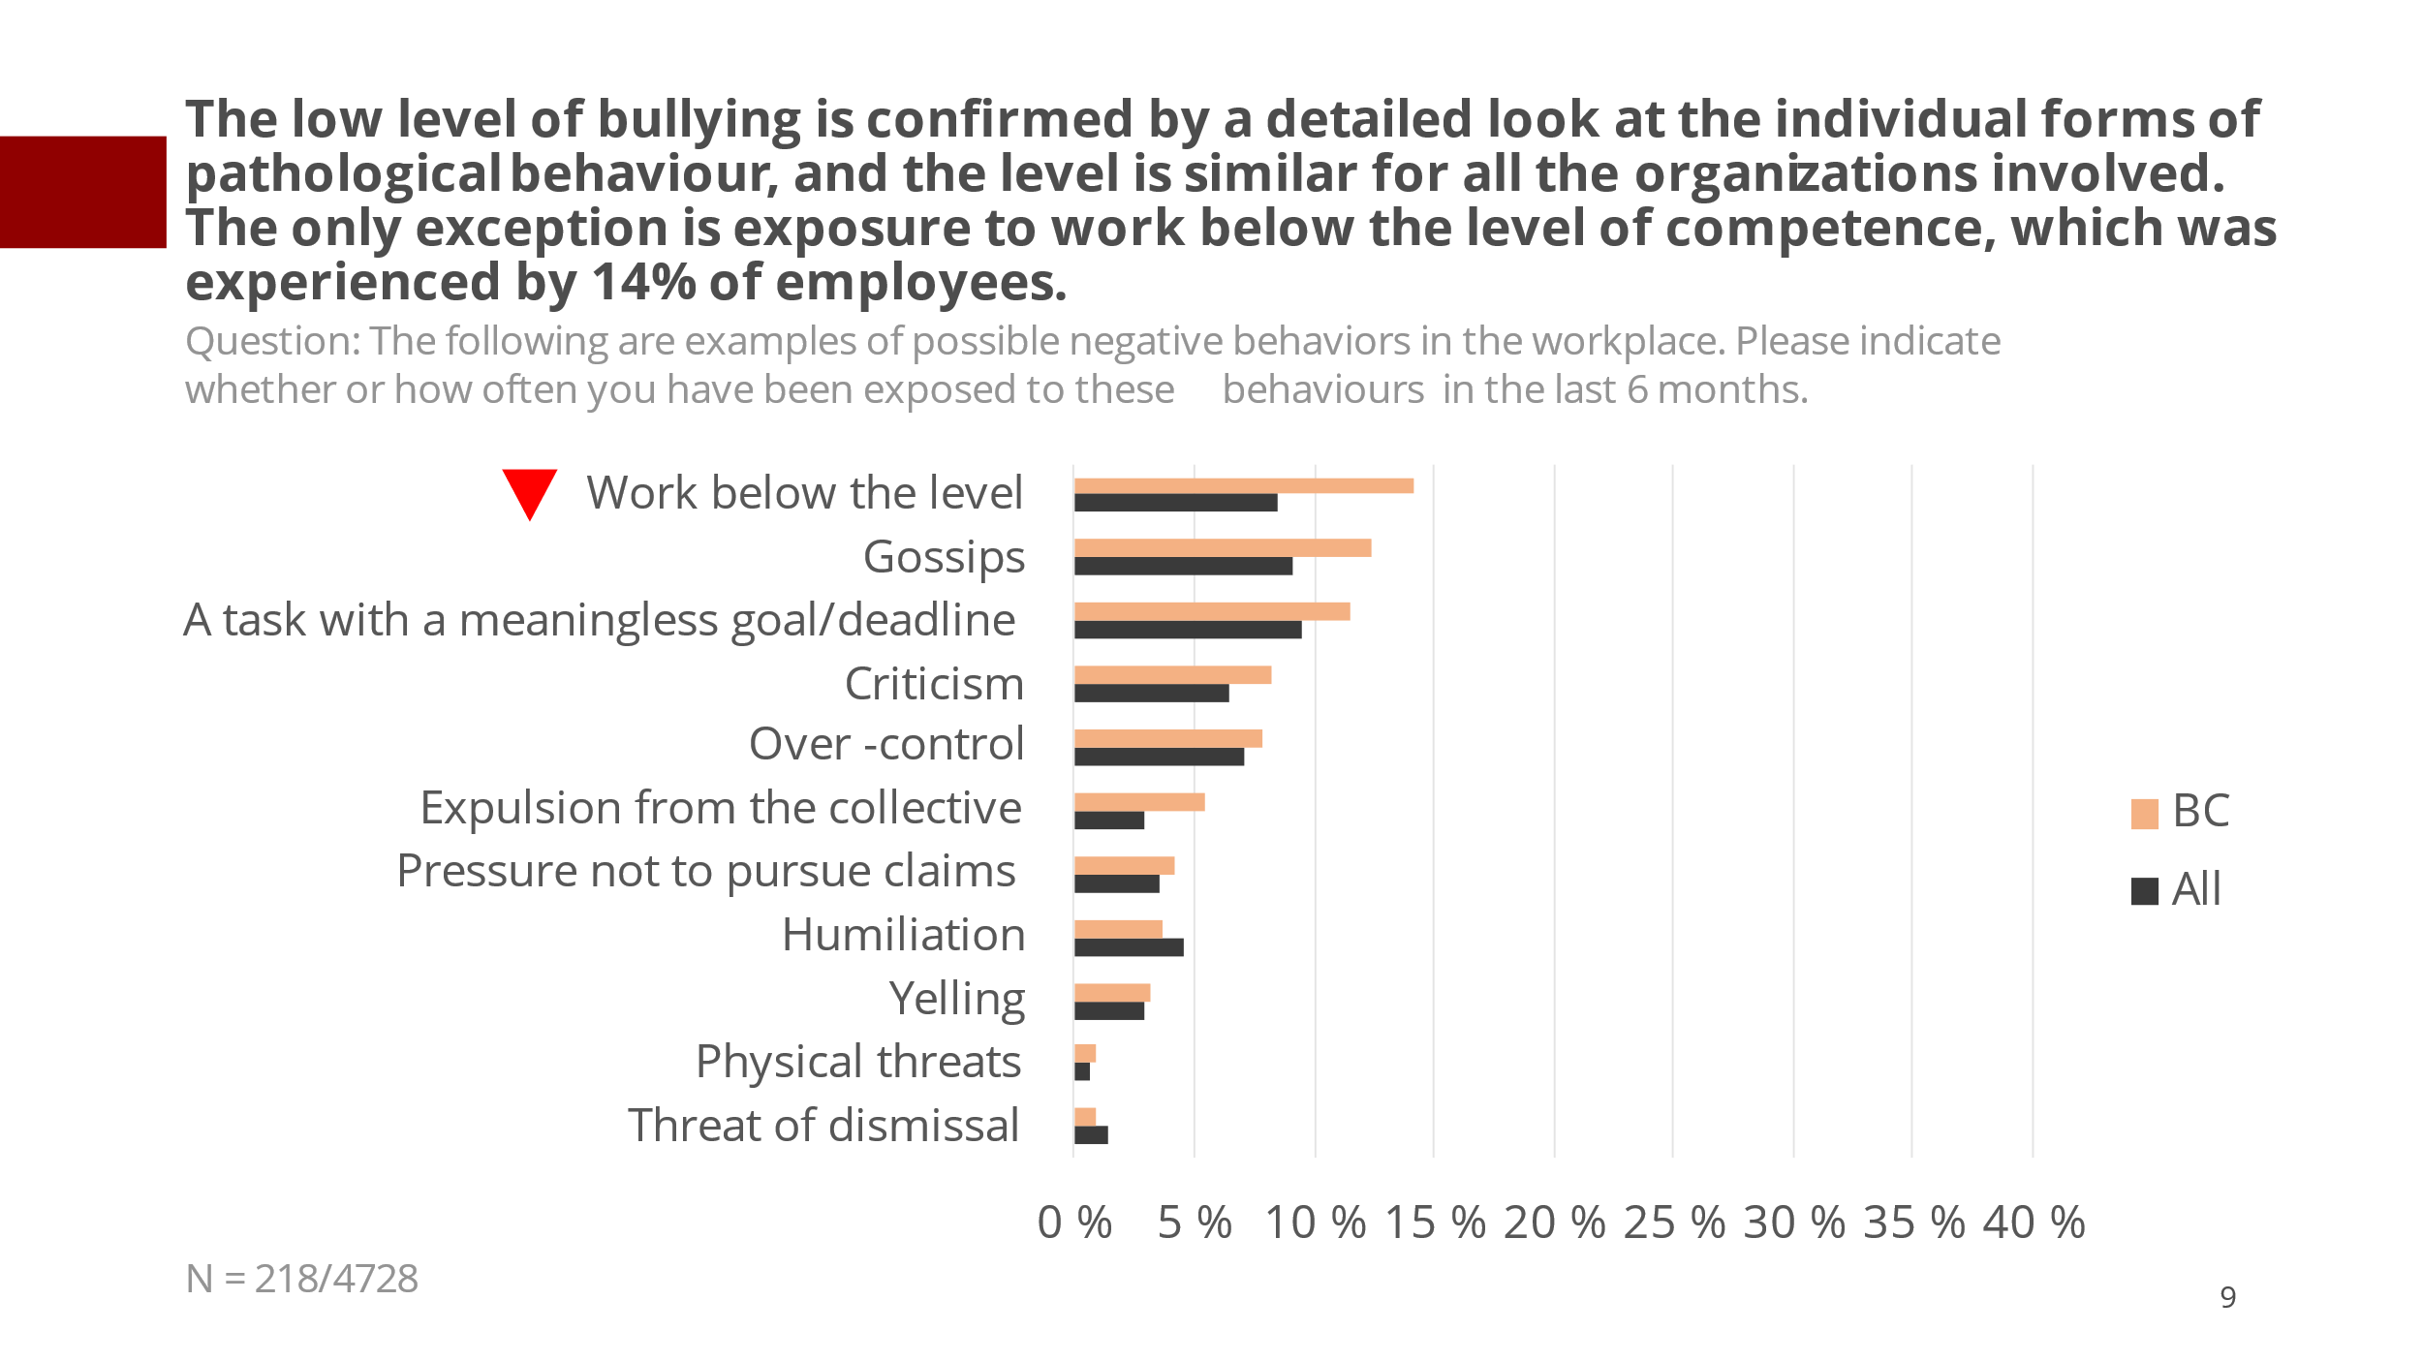
Graph 2
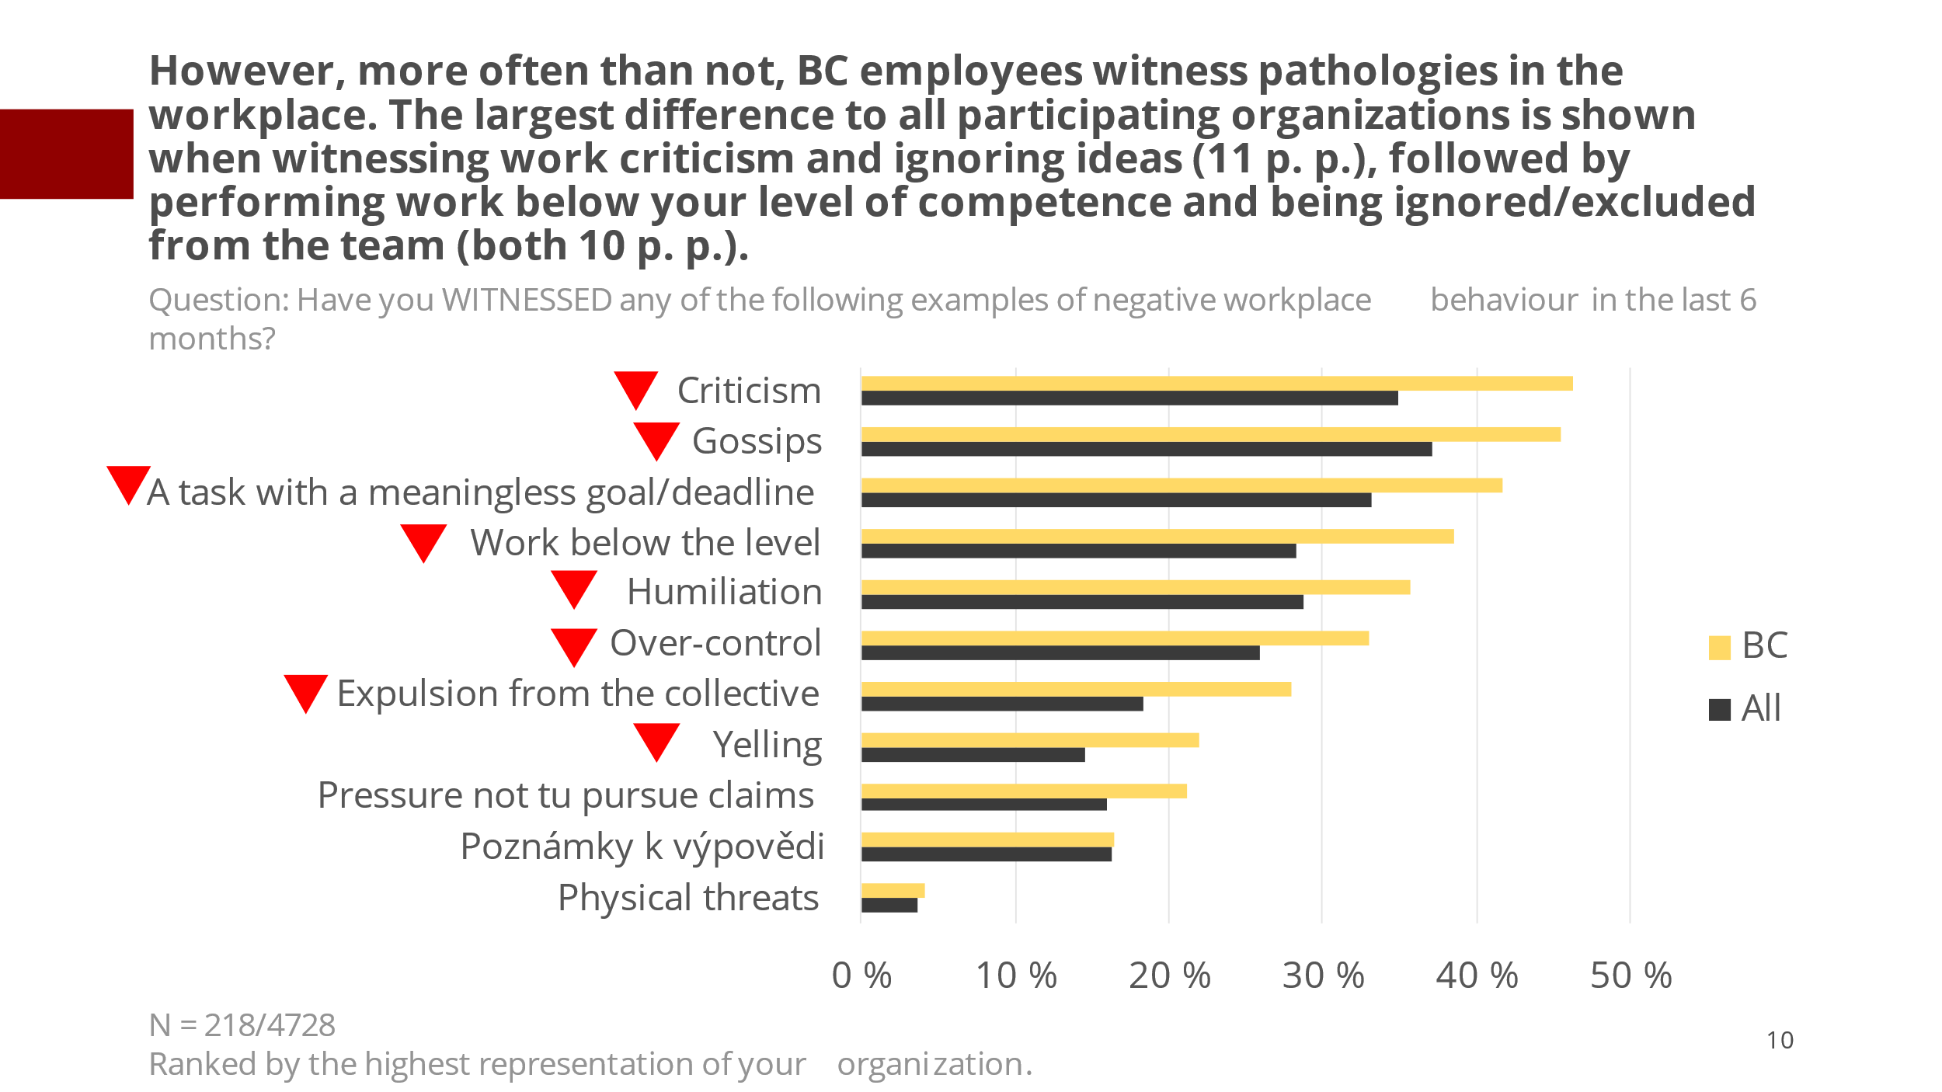
Graph 3
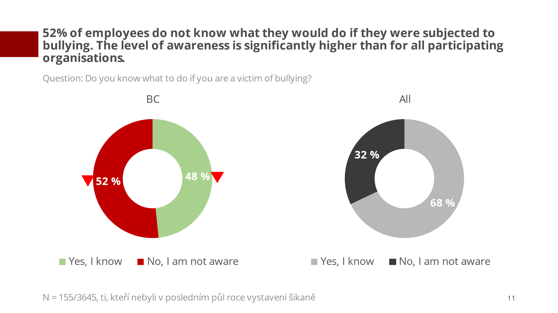
Graph 4

