 |  | Mentoring Programme: List of Mentors  Mentorský program: Seznam mentorů
2024-01-15 Version V01 ● Verze V01
Internal mentors ● Interní mentoři
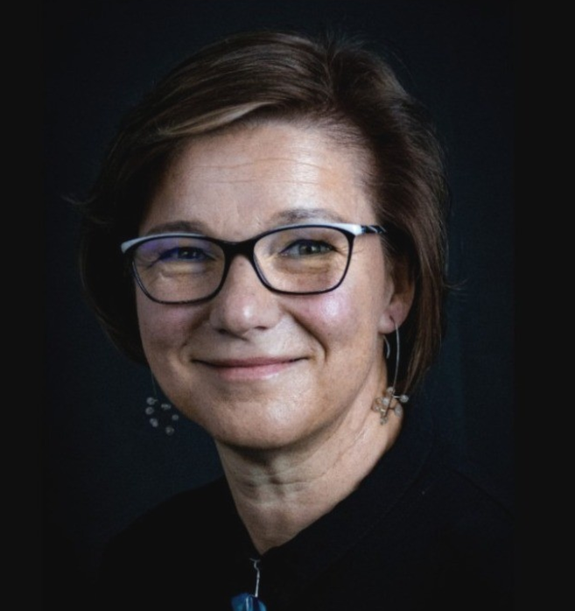 | BASTLOVÁ Daša  Biology Centre CAS, Institute of Plant Molecular Biology, České Budějovice, CZ  Research Manager, HR specialist  dasa.bastlova@umbr.cas.cz  www
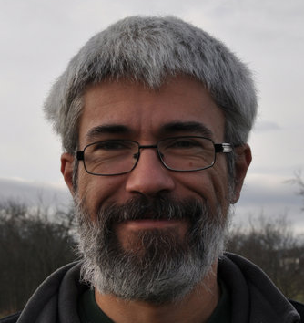 | DOLEŽEL David  Biology Centre CAS, Institute of Entomology, České Budějovice, CZ  Senior group leader in molecular chronobiology  dolezel@entu.cas.cz  www
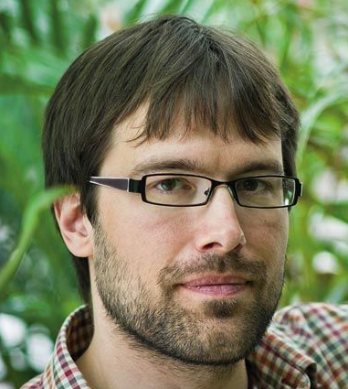 | HRČEK Jan  Biology Centre CAS, Institute of Entomology, České Budějovice, CZ  Junior group leader in experimental ecology  jan.hrcek@entu.cas.cz  www
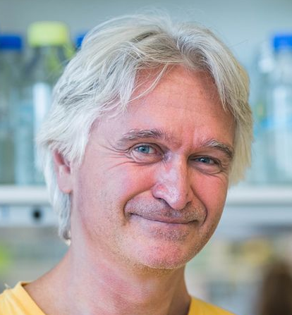 | LUKEŠ Julius  Biology Centre CAS, Institute of Parasitology, České Budějovice, CZ  Senior group leader in molecular biology of protists  jula@paru.cas.cz  www
 | MOZGA Tomáš  Biology Centre CAS, Institute of Plant Molecular Biology, České Budějovice, CZ  CZARMA project manager  tomas.mozga@umbr.cas.cz  www, www
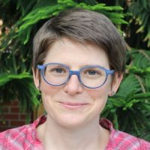 | MOZGOVÁ Iva  Biology Centre CAS, Institute of Plant Molecular Biology, České Budějovice, CZ  Junior group leader in plant epigenetics  iva.mozgova@umbr.cas.cz  www
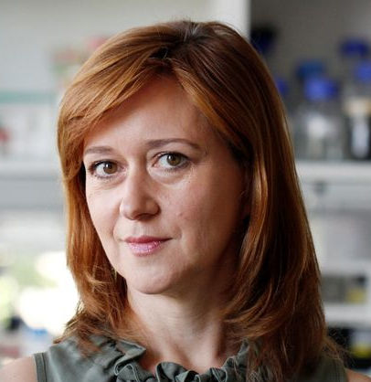 | PANICUCCI ZÍKOVÁ Alena  Biology Centre CAS, Institute of Parasitology, České Budějovice, CZ  Senior group leader in functional biology of protists  azikova@paru.cas.cz  www
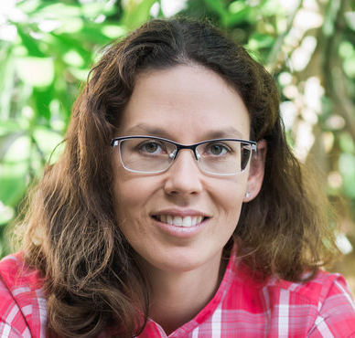 | SAM Kateřina  Biology Centre CAS, Institute of Entomology, České Budějovice, CZ  Junior group leader in multitrophic interactions  katerina.sam.cz@gmail.com  www
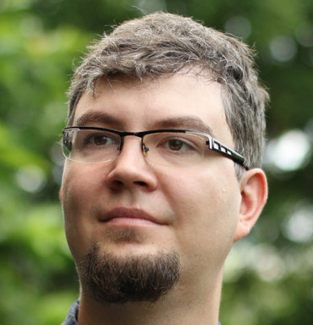 | VOLF Martin  Biology Centre CAS, Institute of Entomology, České Budějovice, CZ  Junior group leader in evolutionary ecology  volf@entu.cas.cz  www
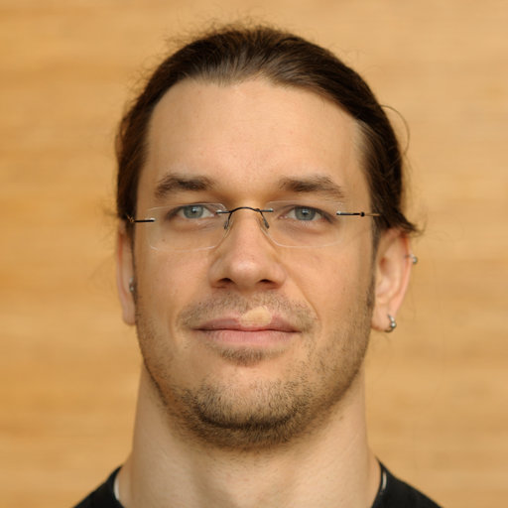 | WRZACZEK Michael  Biology Centre CAS, Institute of Plant Molecular Biology, České Budějovice, CZ  Senior group leader in plant molecular signaling  michael.wrzaczek@umbr.cas.cz  www
External mentors ● Externí mentoři
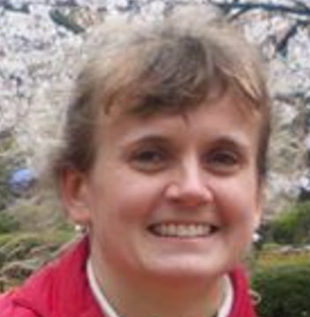 | BÍŠOVÁ Kateřina  Institute of Microbiology CAS, Centre Algatech, Třeboň, CZ  Senior group leader in cell cycles of algae  bisova@alga.cz  www
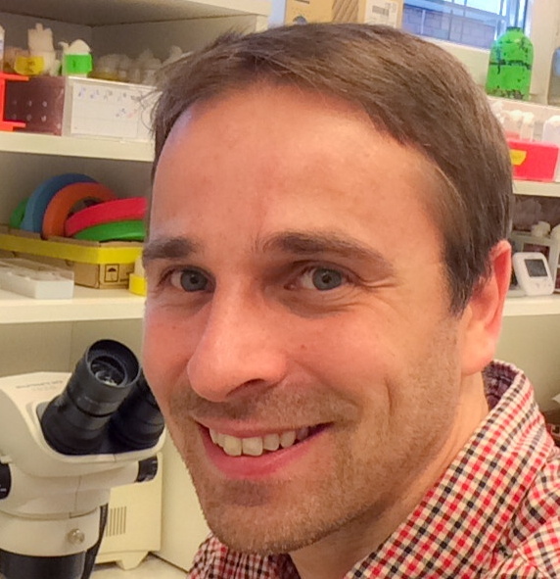 | DOLEŽAL Tomáš  University of South Bohemia in České Budějovice, Faculty of Science, CZ  Senior group leader in molecular integrative physiology in drosophila  tomas.dolezal@prf.jcu.cz  www
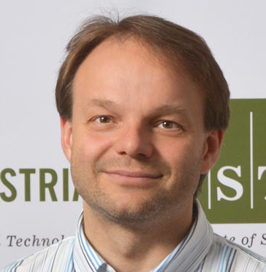 | FRIML Jiří  Institute of Science and Technology Austria, Klosterneuburg, Austria  Senior group leader in developmental and cell biology of plants  jiri.friml@ist.ac.at  www
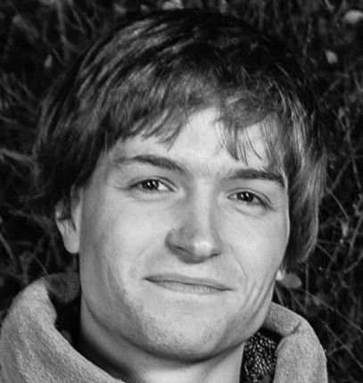 | GLANC Matouš  Czexpats in Science z. s., Prague, CZ  Director  matous.glanc@czexpats.org  www
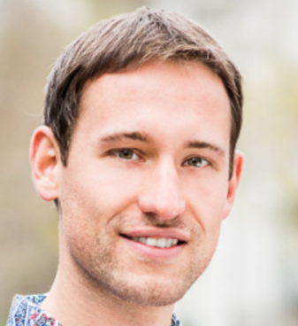 | ICHA Jaroslav  Czexpats in Science z. s., Prague, CZ  Bruker Fluorescence Microscopy  icha.jaroslav@gmail.com  www, www
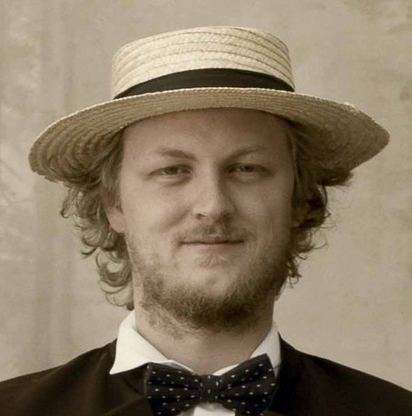 | JANDA Martin  University of South Bohemia in České Budějovice, Faculty of Science, CZ  Junior group leader in molecular plant-microbe interactions  mjanda04@prf.jcu.cz  www
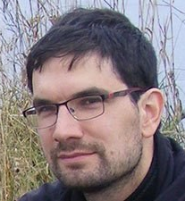 | KOLÁŘ Filip  Charles University, Faculty of Science, Prague, CZ  Junior group leader in plant ecological genomics  filip.kolar@natur.cuni.cz  www
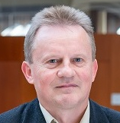 | KOMENDA Josef  Institute of Microbiology CAS, Centre Algatech, Třeboň, CZ  Senior group leader in photosynthesis  komenda@alga.cz  www
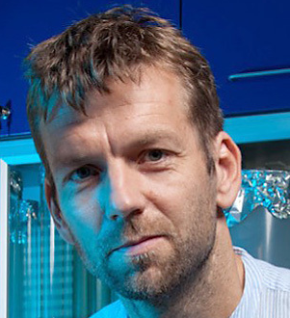 | KREJČÍ Lumír  Masaryk University, Faculty of Science, Faculty of Medicine, Brno, CZ  Senior group leader in  lkrejci@chemi.muni.cz  www
 | LAFON PLACETTE Clément  Charles University, Faculty of Science, Prague, CZ  Junior group leader in plant reproduction evolution  lafonplc@natur.cuni.cz  www
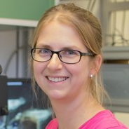 | MUSILOVÁ Zuzana  Charles University, Faculty of Science, Prague, CZ  Junior group leader in animal evolutionary biology  zuzana.musilova@natur.cuni.cz  www
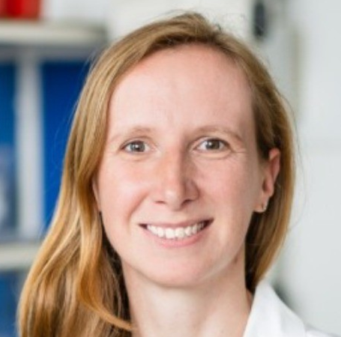 | PETRÁKOVÁ Vladimíra  J. Heyrovský Institute of Physical Chemistry CAS, Prague, CZ  Junior group leader in plasmon-enabled superresolution microscopy and bioimaging  vladimira.petrakova@jh-inst.cas.cz  www
 | POKORNÁ Martina  CEITEC Masaryk University, Brno, CZ  Deputy Director for Administration  martina.pokorna@ceitec.muni.cz  www
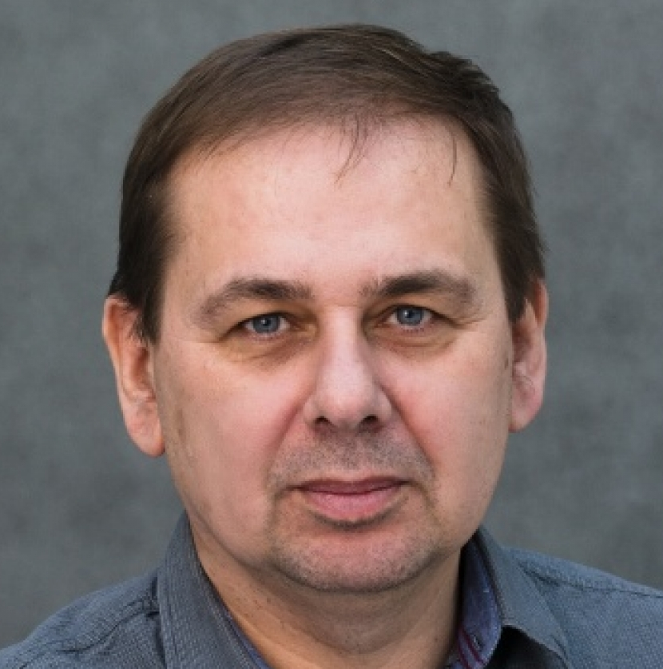 | ŘÍHA Karel  CEITEC Masaryk University, Brno, CZ  Senior group leader in plant molecular biology  karel.riha@ceitec.muni.cz  www
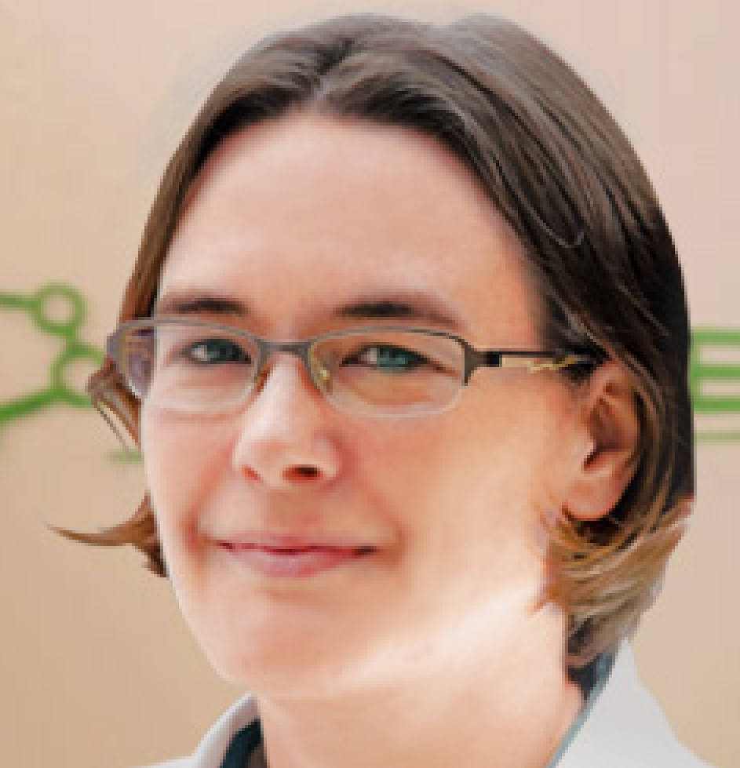 | ROBERT BOISIVON Helene  CEITEC Masaryk University, Brno, CZ  Senior group leader in plant development  helene.robert.boisivon@ceitec.muni.cz  www
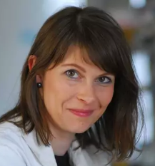 | ROHLENOVÁ Kateřina  BIOCEV, Institute of Biotechnology CAS, Prague, Vestec, CZ  Junior group leader in metabolism of tumor tissue  katerina.rohlenova@ibt.cas.cz  www
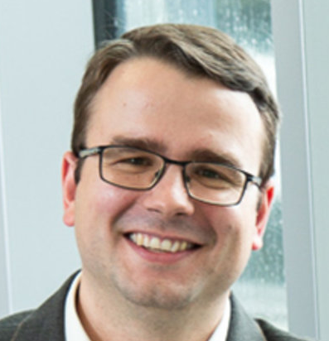 | SLANINA Tomáš  Institute of Organic Chemistry and Biochemistry CAS, Prague, CZ  Junior group leader in redox photochemistry  tomas.slanina@uochb.cas.cz  www
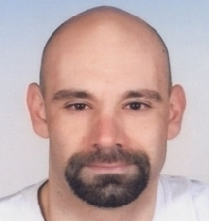 | SOBOTKA Roman  Institute of Microbiology CAS, Centre Algatech, Třeboň, CZ  Senior group leader in photosynthetic pigments  sobotka@alga.cz  www
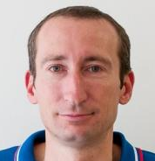 | ŠTĚPÁNEK František  University of Chemistry and Technology Prague, CZ  Senior group leader in chemical robotics  Frantisek.Stepanek@vscht.cz  www
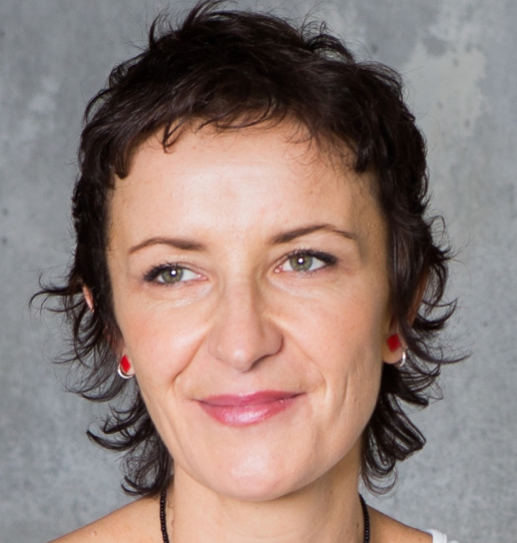 | VAŇÁČOVÁ Štěpánka  CEITEC Masaryk University, Brno, CZ  Senior group leader in RNA quality control  stepanka.vanacova@ceitec.muni.cz  www

