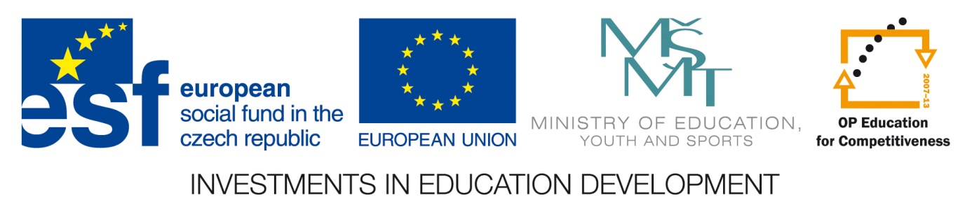
Postdoctoral research fellow position (tutor Vlastimil Křivan)
Project title: Mathematical modeling in ecology
Hosted by: Laboratory of Theoretical Ecology,
Biology Centre of the Academy of Sciences, Czech Republic
The position will be co-financed by the European Social Fund and the state budget of the Czech Republic.
Workplace:
Laboratory of Theoretical Ecology focuses its research on mathematical ecology. The on-going work focuses mainly on integration of mathematical modeling approaches used in behavioral, population, and evolutionary ecology. Methods based on differential equations, game theory, and simulations are used and applied to various problems. You can read more about the Laboratory of Theoretical Ecology on http://www.entu.cas.cz/dtb/. The Lab also fosters collaboration between empiricists and theoreticians.

Position summary:
The fellow will pursue research in mathematical ecology. To this end, it is expected that the successful candidate will be pursuing its own research program, as well as a collaborative research with members of the Lab. Prior experience with mathematical modeling and good knowledge of mathematical methods is necessary. There may be some small teaching load associated with this position.
Duration of contract:
Selected candidate will be offered a position for up to 10 months starting from September, 2014. The salary is about 1800 EUR brutto per month and this amount corresponds to a good living standard in the Czech Republic. Extension of the contract beyond 10 months may be possible, pending renewed funding.
Qualifications:
Interested candidates must have successfully obtained their Ph.D. degree in a relevant discipline after March 29th, 2008. A good knowledge of English language (corresponding to CAE or equivalent) is required. Some knowledge of the Czech language will prove useful.
How to apply:
Interested candidates should apply no later than July 31st, 2014 by submitting the following documents and information to prof. V. Křivan (krivan@entu.cas.cz), C/c to B. Švehla (svehla@bc.cas.cz): (1) Cover letter explaining the candidate’s research interests; (2) Detailed CV including a list of publications and other achievements; (3) Certified academic transcripts and diplomas (scanned copies); (4) List of minimally two referees who can testify on the candidate´s character and performance; (5) Declaration of the candidate’s proficiency in English.
Announcement of results:
The Evaluation Committee will convene in August 2014 and candidates will be immediately informed of the results.

